Inheritance->

* **Inheritance in java** is a mechanism in which one object acquires all the properties and behaviors of parent object.

* The idea behind inheritance in java is that you can create new classes that are built upon existing classes.

* When you inherit from an existing class, you can reuse methods and fields of parent class, and you can add new methods and fields also.

Inheritance represents the **IS-A relationship**, also known as *parent-child* relationship.

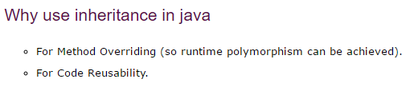

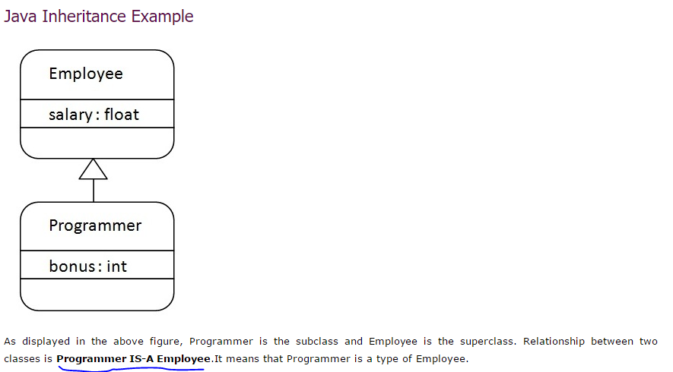

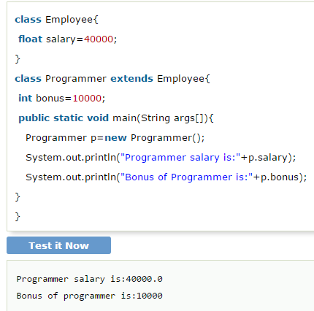

Extends keyword->



Types of inheritance->

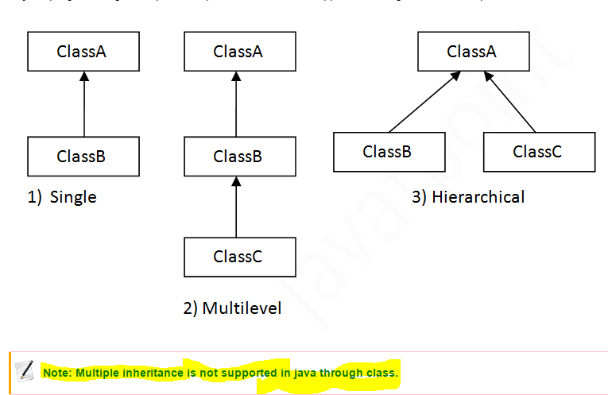

***********if u don’t put correct main method then code doesn’t run:

1.single implementation->

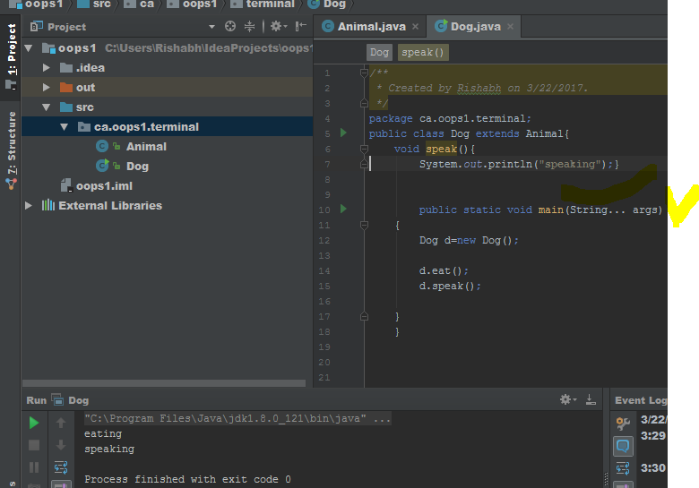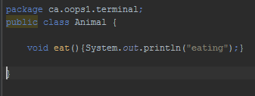

3.multilevel inheritance->

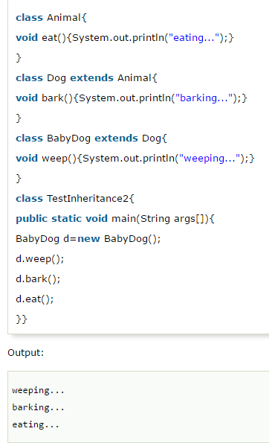

3.hirarchy->

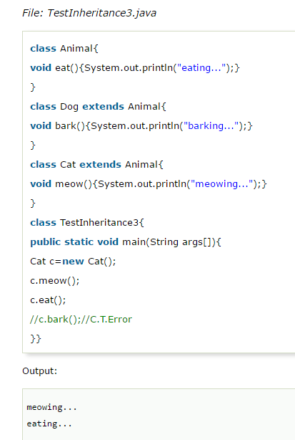

Q.why multiple inheritance not supported?

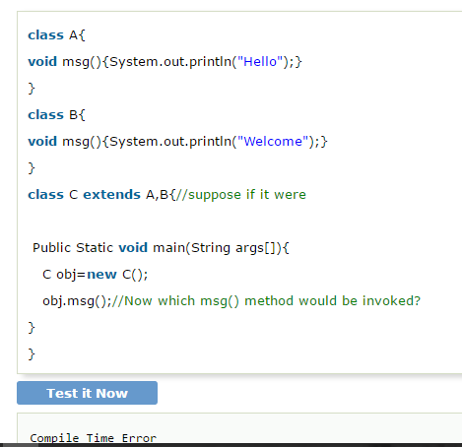

Aggregration in java or (HAS-A) relation->

Employee object contains many informations such as id, name, emailId etc. It contains one more object named address, which contains its own informations such as city, state, country, zipcode etc. as given below.

Means when a class contains other class objects;

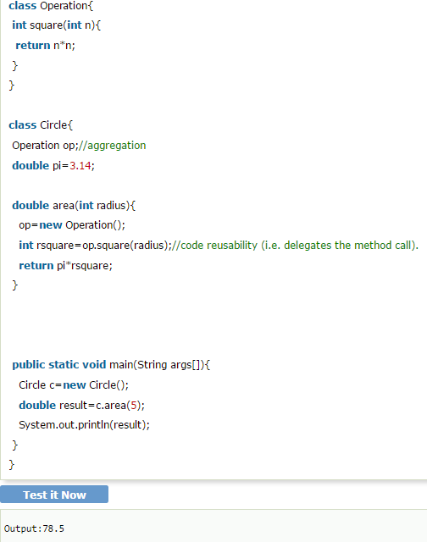

Understanding meaningful example of Aggregation->

1st class->

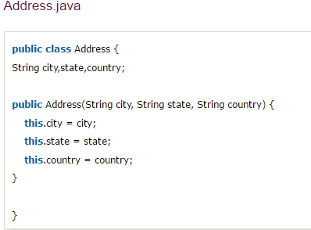

2nd class->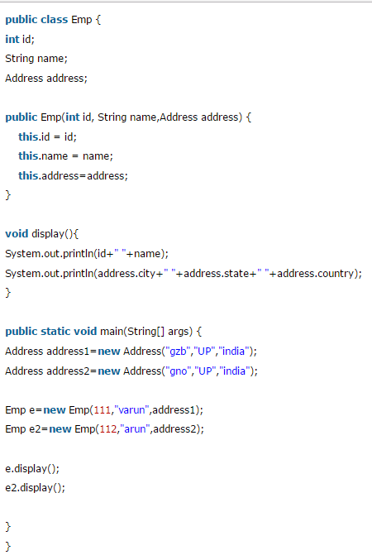

Here the 1st class object is under the 2nd class;

3.output->